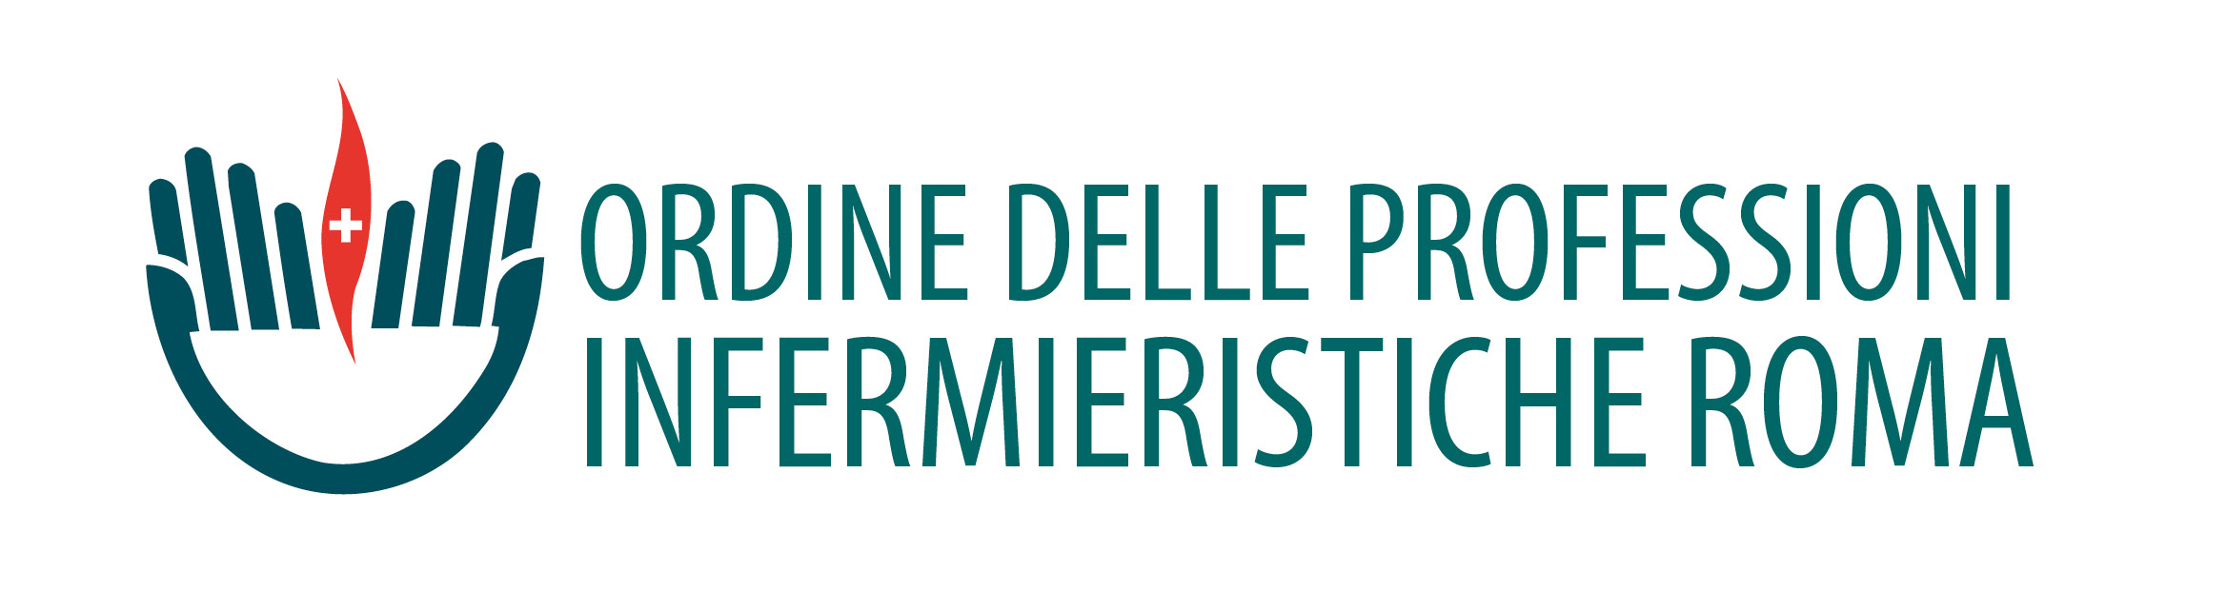
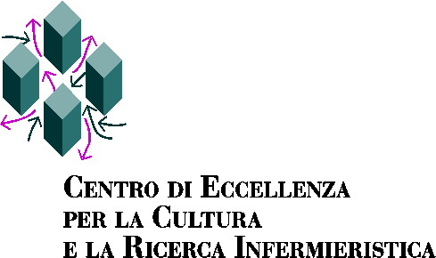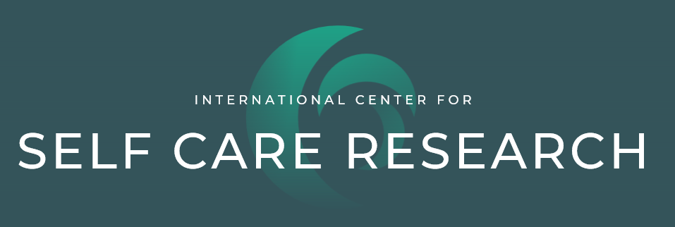

Self-care in chronic illnesses: third international meeting
June 16th 2021
online event: click on the following link

Self-care in chronic illnesses: thirdinternational meeting - YouTube

The constant increase of chronic diseases represents a challenge for patients, families and health systems. Because of chronic diseases, patients are at risk of lower quality of life, families have to manage complex situations, and health systems have to face increasing expenses. These issues can be addressed if patients and their families perform self-care which aims to keep stable chronic diseases, monitoring signs and symptoms and responding to signs and symptoms of exacerbations. Evidence shows that an adequate self-care improves chronic disease outcomes such as mortality, quality of life and inappropriate re-hospitalizations.

Since 2009, Nursing faculty members at the University of Rome "Tor Vergata" and the Center of Excellence for Nursing Scholarship in Rome have developed a research program on self-care in chronic diseases. This workshop, which will be held remotely, aims to share the knowledge produced so far with the professional community in an international perspective.

Organizing Committee
Rosaria Alvaro, Maddalena De Maria, Marco Di Nitto, Angela Durante, Carlo Turci, Ercole Vellone

Program

9:00 Introduction to the workshop

Prof. Orazio Schillaci, Prof. Paolo Di Francesco, Prof. Antonino De Lorenzo, Dott. Maurizio Zega, Dott. Gennaro Rocco

First Session Self-care research in Italy (This session will be in Italian)

Chairs: Rosaria Alvaro, Ercole Vellone

9:30 – 10:00 Introduzione: La ricerca sul self-care in Italia
Ercole Vellone

Ore 10:00 – 13:30 Il Self-care nelle cronicità

Maddalena De Maria Self-care e malattie croniche multiple

Angela Durante Self-care e ruolo dei caregiver
Angela Cuoco

Marco Clari Self-care e BPCO

Michela Luciani Self-care e diabete

Giulia Villa Self-care e stomie intestinali e urinarie

Marco Di Nitto Self-care nel trattamento con chemioterapici orali

Alessio Conti Self-care e lesioni midollari

Barbara Bassola Self-care e malattia del motoneurone

Ore 13:00 – 13:30 Discussione

Second Session International perspectives on self-care (This session will be in English)

Chairs: Maria Matarese, Davide Ausili

Ore 15:00 – 15:30 The Middle Range Theory of Self-Care in Chronic Illnesses: news and updates
Barbara Riegel, PhD, RN, FAAN, FAHA

Ore 15:30 – 16:00 How symptoms influence self-care in chronic conditions
Christopher S. Lee, PhD, RN, FAHA, FAAN, FHFSA

Ore 16:00 - 16:30 Self-care: a dyadic phenomenon
Karen Lyons, PhD, FGSA

Conclusions

Speakers

- Rosaria Alvaro, Professor of Nursing, Università di Roma “Tor Vergata”
- Davide Ausili, Assistant Professor of Nursing, Università di Milano-Bicocca
- Barbara Bassola, Tutor, Università di Milano
- Marco Clari, Assistant Professor of Nursing, Università di Torino
- Alessio Conti, Research Fellow, Università di Torino
- Angela Cuoco, PhD student, Università di Roma “Tor Vergata”
- Antonino De Lorenzo, Director Department of Biomedicine and Prevention, Università di Roma “Tor Vergata”
- Maddalena De Maria, Research Fellow, Università di Roma “Tor Vergata”
- Paolo Di Francesco, Dean, School of Medicine, Università di Roma “Tor Vergata”
- Marco Di Nitto, Research Fellow, Università di Roma “Tor Vergata”
- Angela Durante, Research Fellow, Università di Roma “Tor Vergata”
- Christopher S. Lee, PhD, RN, FAAN, FAHA, Associate Dean for Research and Professor; Boston College, Connell School of Nursing, Boston, USA
- Michela Luciani, Research Fellow, Università di Milano-Bicocca
- Karen Lyons, PhD, FAGS, Associate Professor, Boston College, Connell School of Nursing, Boston, USA
- Maria Matarese, Associate Professor, Università Campus Biomedico, Roma
- Gennaro Rocco, Director, Center of Excellence for Nursing Scholarship, Rome
- Orazio Schillaci, Rector, Università di Roma “Tor Vergata”
- Barbara Riegel, PhD, RN, FAAN, FAHA, Edith Clemmer Steinbright Professor of Gerontology, School of Nursing, University of Pennsylvania, Philadelphia, USA; Co-Director International Center for Self-Care Research
- Carlo Turci, Nursing Board, Rome
- Ercole Vellone, Associate Professor, Università di Roma “Tor Vergata”
- Giulia Villa, Assistant Professor, Università San Raffaele, Milano
- Maurizio Zega, President Nursing Board, Rome

