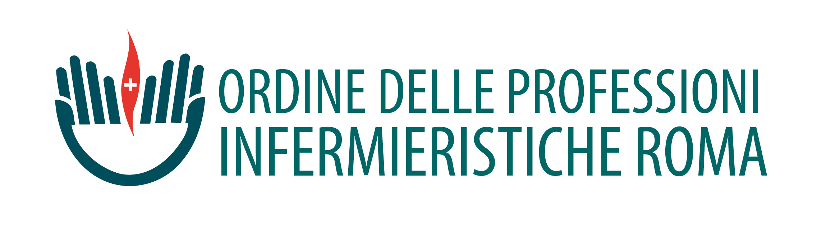
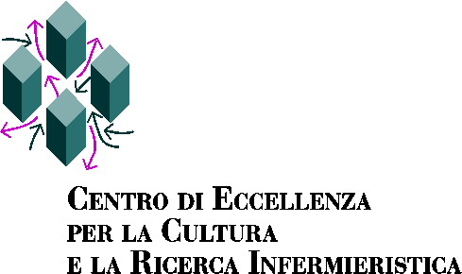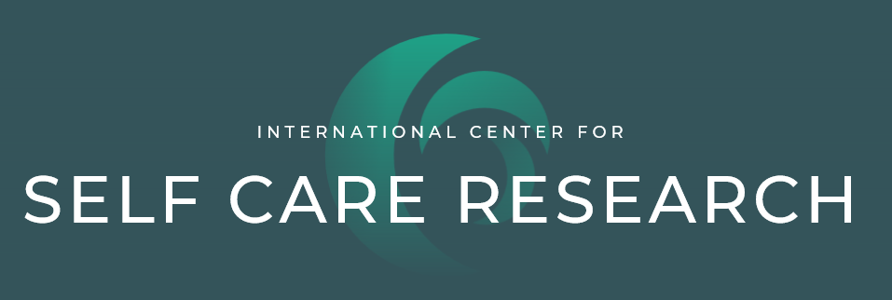

Workshop

Self-care in chronic illnesses: third international meeting
(Preliminary program)
10 June 2020

Aims of the workshop
- To share current knowledge on self-care in chronic conditions in an international perspective;
- To define future research projects on self-care

Workshop venue
University of Rome “Tor Vergata, Rome, Italy; Faculty of Medicine, Via Montpellier, 1, Room Fleming.

Participants
The workshop is open to people who are interested in self-care research and PhD students in particular.

Languages: Italian and English

9:00 – 9:30 Introduction to the workshop and greetings from The Rector of the University of Rome Tor Vergata, the Dean of the Faculty of Medicine, the President of the Nursing Board and the Director of the Center of Excellence for Nursing scholarship.

Session I International perspectives on self-care
Chairs: Rosaria Alvaro, Ercole Vellone

9:30 – 10:50 The Middle Range Theory of Self-Care in Chronic Illnesses: news and updates
Barbara Riegel, PhD, RN, FAAN, FAHA
9:50 – 10:10 How symptoms influence self-care in chronic conditions
Christopher S. Lee, PhD, RN, FAHA, FAAN, FHFSA
10:10- 10:30 Self-care: a dyadic phenomenon
Karen Lyons, PhD, FGSA
10:30 – 10:45 Discussion with participants
10:45 – 11:00 Coffee break

Session II Italian research projects on self-care
Chairs: Maria Matarese, Davide Ausili

11:00 – 11:15 Self-care in persons with multiple chronic conditions
Maddalena De Maria
11:15 – 11:30 Self-care in persons with COPD
Marco Clari, PhD
11:30 – 11:45 Self-care in persons with diabetes
Michela Luciani, PhD
11:45 – 12:00 Self-care in persons with stoma
Giulia Villa, PhD
12:00 – 12:15 Self-care in persons with motoneuron diseases
Barbara Bassola, PhD
12:15 – 12:30 Self-care in persons treated with oral chemotherapy
Marco Di Nitto, MSN
12:30 – 12:45 Self-care and role of informal caregivers
Angela Durante
12:45 – 13:00 Self-care in persons with spinal cord injury
Alessio Conti

13:00 – 14:00 Lunch

Session III Future developments on self-care research
Chairs: Rosaria Alvaro, Ercole Vellone, Maria Matarese, Davide Ausili, Barbara Riegel, Christopher S. Lee, Karen Lyons.

14:00 – 17:00 Workgroups with participants to define future studies on self-care

Contact: People who are interested to attend this workshop should contact
Prof. Ercole Vellone, ercole.vellone@uniroma2.it

